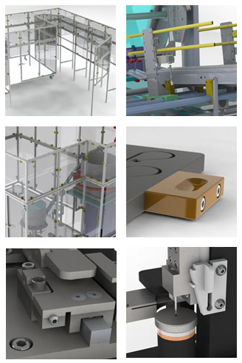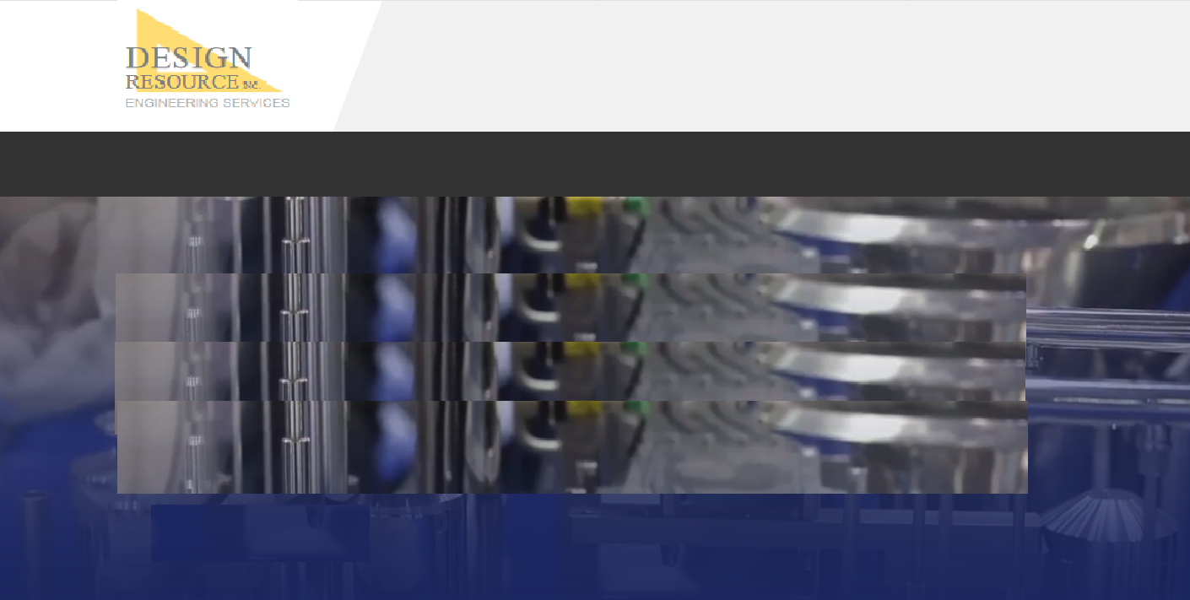

**HOME | ENGINEERING | STAFFING | COMPANY | CONTACT**

**© 2019 DESIGN RESOURCE, INC.**

Can these pics hover to a temporary full, larger image while the mouse is over them?

**Machine design**

* Intermittent or continuous motion
* Motion control systems
* Work cells or lines
* Material handling
* Control system layout and design
* Safety enclosures
* PLC programming

**Tooling and Fixtures**

* Robust solutions for the toughest positioning and assembly problems.
* Clean room tooling (medical and high tech)
* Assembly tooling
* RSW tooling
* Laser Weld tooling
* Inspection tooling

**Mechanism Design**

**Process and manufacturing equipment**

**Process development**

***Complete turnkey manufacturing solutions to bring your project from initial concept through final build.***

**MANUFACTURING ENGINEERING**

**HOME ENGINEERING STAFFING COMPANY CONTACT**